DATABASE SCREEN SHOT: | GUIDANCE NOTES:
  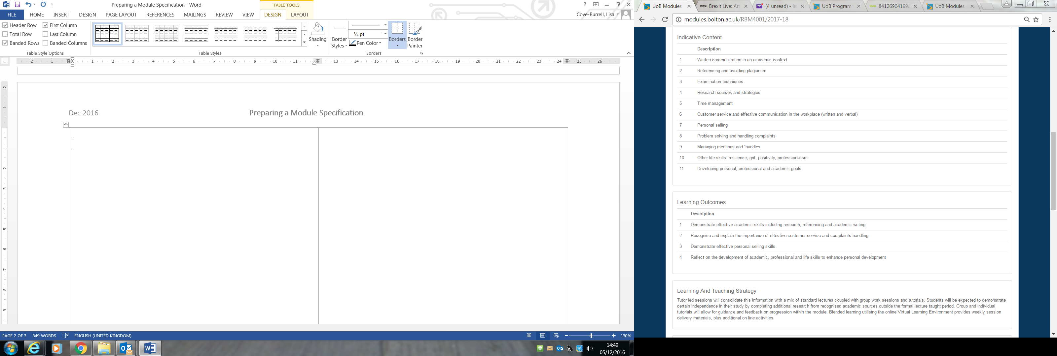 | Module Codes: Module codes are generated by Student Data Management. Off-campus partners should contact their Partnership Management Team at the University of Bolton. You should not ask for a code to be generated until the programme/change has been given academic approval. The 3 letter prefix should be taken from the host programme name. The first number after the prefix indicates the level. Once a module code is generated, you will be able to populate its fields on the database.
Module Type, Size and Duration: You can choose from a number of module types on the drop down menu: Standard, Dissertation, Placement, Work-based learning etc.
The duration of a module is usually one or two semesters. Please do specify weeks unless agreed by SEO. If opting for a two semester delivery of a standard module, a justification is likely to be required at approval.
 | Pre-Requisites, Co-requisites and Barred Combination: Pre-requisites and co-requisites should be used sparingly with justification provided at approval.
Marking Scheme: Options on the dropdown menu are: Numeric mark scheme, Grade mark scheme i.e. P, F, L or I grade, Combination of numeric marks and grades.
If a numeric mark scheme is selected, then the pass mark needs to be specified. This is usually 40% for undergraduate modules and 50% for postgraduate modules. Some programmes and modules will deviate from the standard due to professional and/or practical requirements.

ECTS (European Credit Transfer and Accumulation System) are equivalent to half the CAT credit value and are automatically calculated by the database
 | Academic Year: Select the year in which the programme will start from the drop-down menu.
Module Outline: It is recommended that this section is written after the rest of the module specification has been finalised. The Module Outline will need to reflect what is specified in the module contents and module learning outcomes. Clear, student-friendly terminology is advised.
In this section explain how the module is current (CONTEMPORARY), will consolidate learning (CONSOLIDATION) and how the module components reinforce one another (COHESION)

Indicate which GAME (UG) or GAME+ (PG) attributes will be assessed in the module (up to 2 GAME attributes for a 20 credit module, 3 attributes to for a 30 credit module etc.) – Map GAME and GAME+ by programme level before specifying.
Indicative Content: List the topics/areas of study and skills development which will be covered in the delivery in clear and simple terms. Ensure that current topics are covered (CONTEMPORARY)
Check topics/areas of study and skills development include the necessary content to meet the module learning outcomes and the GAME/GAME+ attributes listed.
Learning Outcomes (LOs): Specify 3 LOs per 20 credit module and 4 or 5 LOs per 30 credit module.
Start each LO with a verb which is appropriate to the level. Examples: Level 3 and HE4: explain, describe, discuss, outline. HE5: Analyse, appraise, compare and contrast. HE6 and HE7: Critically appraise, critically evaluate, synthesise. HE7 also include: Solve complex problems, develop creative or innovative solutions/recommendations. (CHALLENGE)
See: https://www.qaa.ac.uk/en/quality-code/qualifications-and-credit-frameworks
Ensure learning outcomes are specific, measurable, valid and fair.
Specific: Avoid including LOs which repeat general expectations, such as those laid out in the General Assessment Guidelines e.g. “Demonstrate effective Harvard referencing”, “Use appropriate learning resources to conduct secondary research” etc.- unless these relate to a skills module.
Measurable: Avoid starting with verbs such as “appreciate” and “understand”. How can these be easily measured? Valid: Avoid LOs which don’t challenge the students to the required expectations e.g. “Demonstrate xxx practical skills”. Alternative: “demonstrate effective xxx practical skills in response to a given brief” (CHALLENGE) Fair: Avoid LOs which are reliant on factors outside a student’s control e.g. “demonstrate effective team outcomes” ALTERNATIVE: “contribute effectively to a team event” and “critically reflect on your team-working skills”
Other considerations: Do not specify the assessment type in the LO, e.g. “produce a portfolio”, “write an essay”. However, it is important that the LOs can be assessed by the assessment type.
Refer to the University’s Best Practice Guide to Curriculum Design
Learning and Teaching Strategy: This section might include general text which is relevant to standard modules within a programme. E.g. This module will be delivered through a combination of a number of learning and teaching methods including: lectures, seminars, workshops and tutorials. Delivery will be supported by online discussions and activities posted on the VLE. You will be expected to attend all scheduled sessions and prepare for these in advance by undertaking relevant research and background reading. A general statement will allow a module tutor to tailor-make deliveries (COHORT), which can be outlined in more detail in the Module Guide. N.B. Such text will not exclude activities such as flipped classrooms, visits, guest speakers etc. However, if such learning opportunities are specified in the strategy statement, then these MUST be provided in every delivery of the module. In some cases, the learning and teaching strategy will need to be more specific because of the nature of the module – particularly in relation to project and work-based learning modules.
Refer to the University’s Best Practice Guide to Curriculum Design

 | Learning and Teaching Methods: Please refer to the standard hours document issued by SEO. The total of the scheduled, independent and placement hours should equate to 10 hours per unit of credit, e.g. 300 hours per 30 credit module.
 | Formative Assessment Strategy: Formative assessment is assessment for which feedback is provided to help students “​​​​learn more effectively and find ways to maintain and improve their progress. It does not contribute to the final mark, grade or class of degree awarded to the student.” (QAA 2016). Examples of formative assessment include presentations of work in progress, quizzes, phase tesst, proposals and assessment plans. The formative assessment strategy section might include general text which is relevant to standard modules within a programme, e.g. Formative assessment is employed to support your learning on the module, allowing you to reflect on feedback on your progress from your tutors and peers. It takes a variety of forms including xxxx and does not contribute to the final module mark. Such a statement will allow flexibility in in formative assessment, which can be outlined in more detail in the Module Guide (COHORT). In some cases, the formative assessment strategy will need to be more specific because of the nature of the module.
Summative Assessment Strategy: Here a brief summary of the module’s assessment methods is provided. It is important that the summary matches the descriptions in the Summative Assessment section below and reflects the LOs being assessed. Plan the assessment strategy for the programme as a whole. Ensure that assessments effectively consolidate learning (CONSOLIDATION), and are authentic, accessible and secure. Where possible allow for some optionality in relation to the assessment type, e.g. written piece, verbal assessment, and focus (CHOICE).
Normally* two pieces of assessment are required for a 20 credit or 30 credit module, and three or four assessments for a 40 credit module. Having more than one assessment piece per module allows feedback on an earlier assessment to inform a later one and avoids the problem of bunching of deadlines at the end of a teaching period. For a 20 credit module consider having a smaller assessment which either informs or extends the learning of a larger assessment. *If a number of small items of assessment are required, these can be incorporated into one portfolio assessment however.
When writing the strategy, don’t be too specific about the assessment required – Details can be provided in the Module Guide (COHORT).
Refer to the University’s Best Practice Guide to Curriculum Design
Summative Assessment: It is important that the information matches the descriptions in the Summative Assessment Strategy section
Refer to the University’s Best Practice Guide to Curriculum Design
The following word count is recommended for written assessments: Level 3: 2500 words per 20 credit module. HE4: 3500 words for 20 credit module. HE5: 4000 words per 20 credit module. HE6: 4000 words for 20 credit module. HE7: 4500 words for 20 credit module.
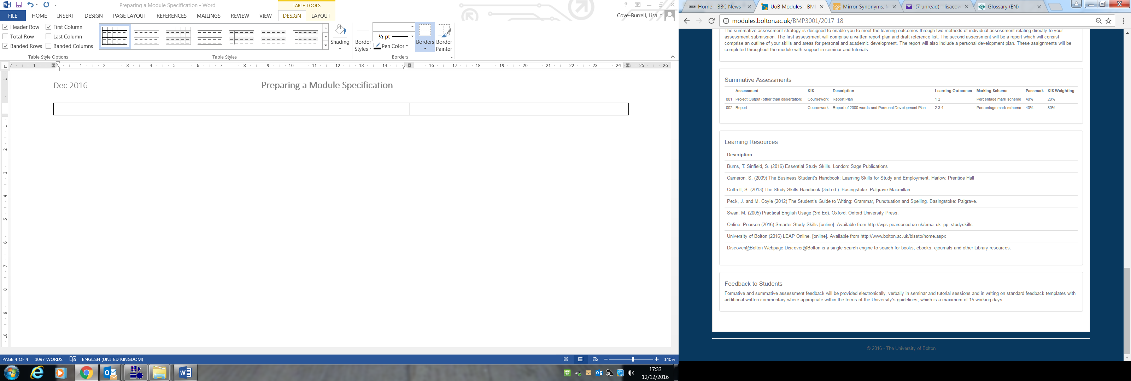 | Learning Resources  Ensure that the resource list includes the most recent sources (CONTEMPORARY)  Identify: Essential Resources (maximum of three), Recommended Resources (maximum of six) – include journal articles as well as text books.  For modules on programmes delivered at the University Bolton campus, complete the Resource List form available via https://libguides.bolton.ac.uk/academic-staff/resource-lists and send it to the Library via library-requests@bolton.ac.uk. Then provide a link to the online resource list under Learning Resources. Where a module is also being run in other geographical locations with differentiated resource lists, please also add the following text under learning resources: Where this module is delivered in a different location to the University Bolton campus, a differentiated resource list can be found in the Module Guide.  For modules on programmes delivered solely at a partner location, list the resources using the standard University of Bolton referencing style as this is what we expect of students– see: https://libguides.bolton.ac.uk/resources/referencing/.
Feedback to Students:
Here standard text can be inserted:
Formative and summative assessment feedback will be made available both verbally and in written form. Feedback will be provided within the terms of the University’s guidelines provided in the Module Guide.

