How to respond to EE reports using Qualtrack

- Log on to https://qualtrack.bolton.ac.uk/

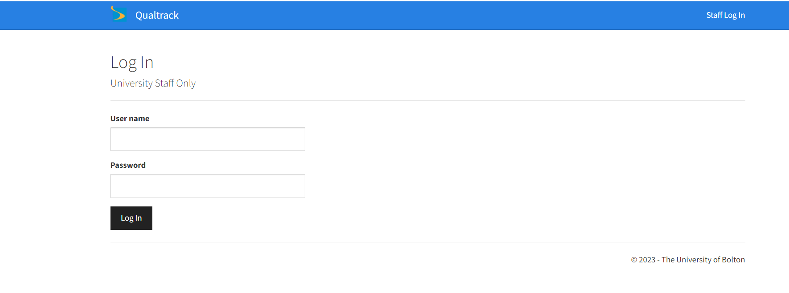
- This will bring up a list of programmes you are responsible for
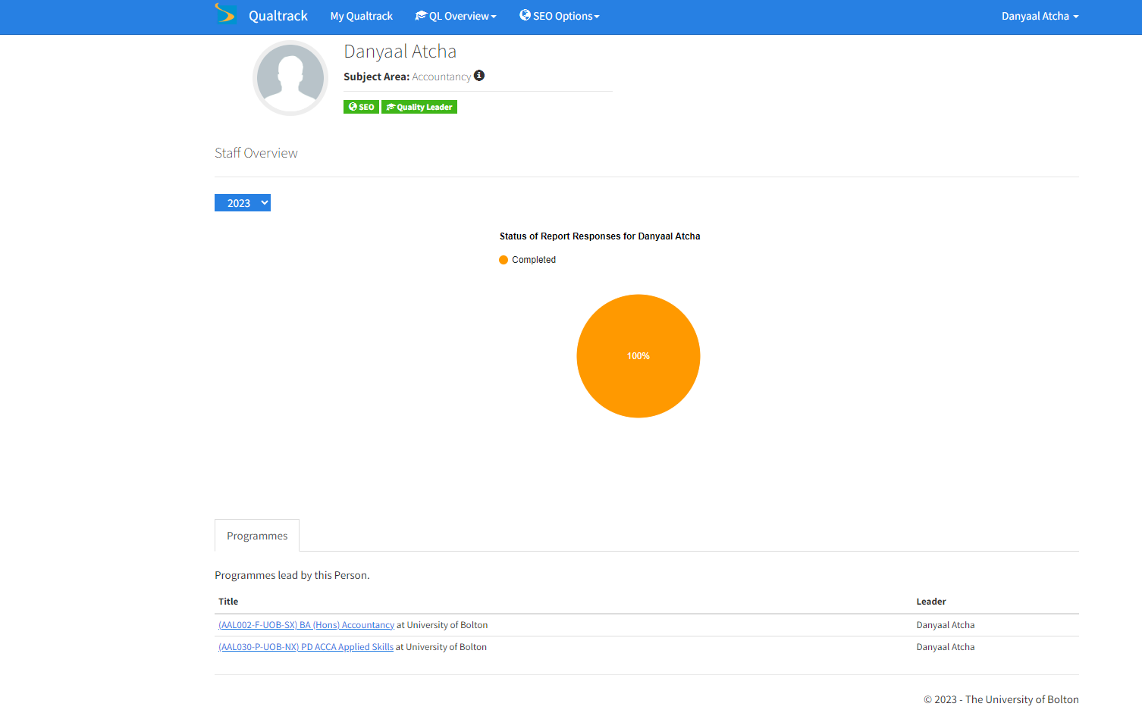
3. For this example, we have used Accountancy. The below screenshot shows the number of departmental responses as a pie chart from 2023 highlighting 100% of responses are completed.

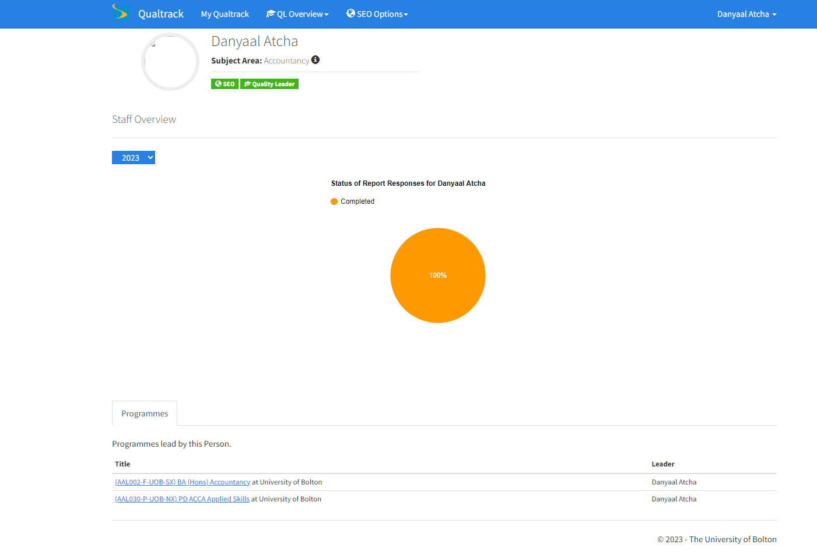

If a response to a report requires completion please click on the name of the programme to take you onto the following screen.

- Please ensure the correct year is selected and then please press add response

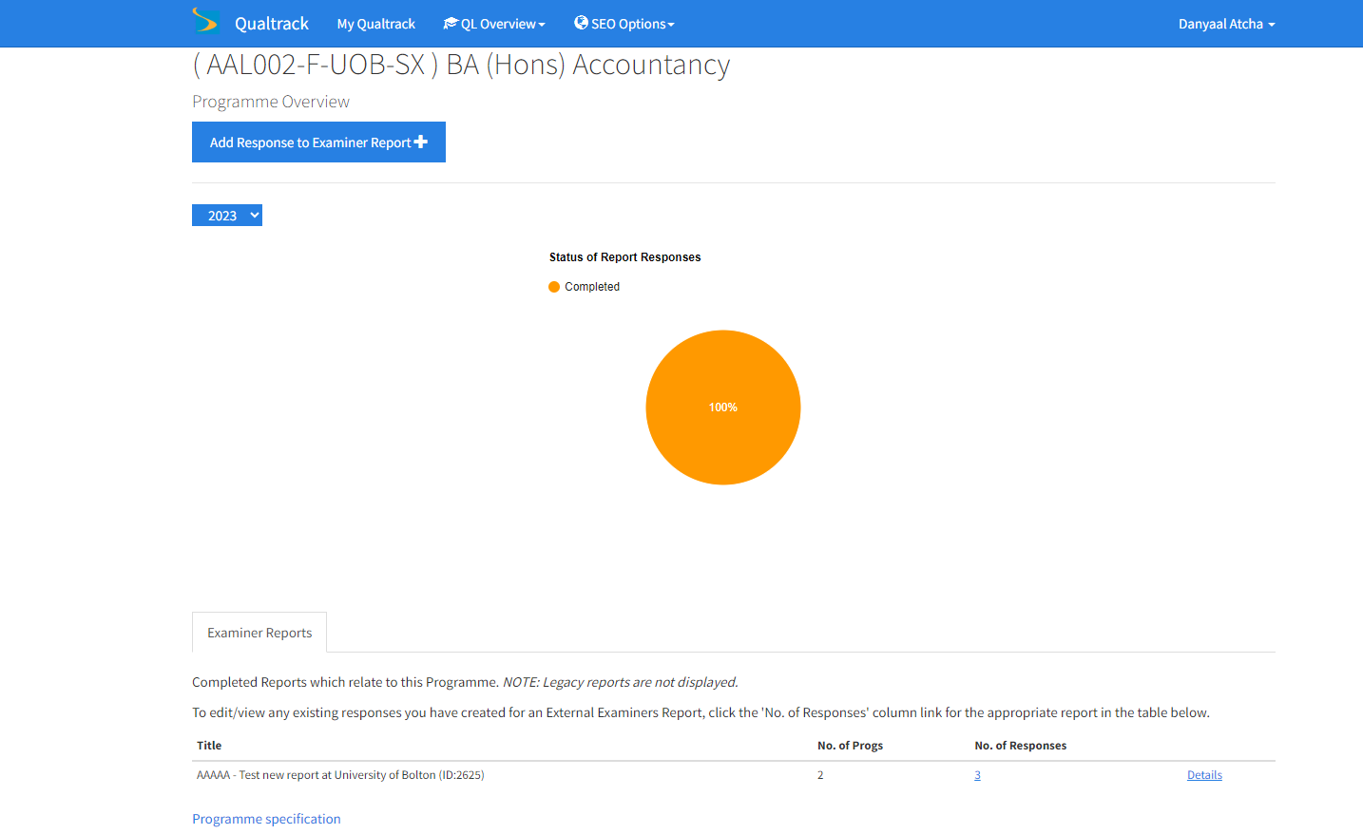

If you wanted to view the reports and responses from previous years then please select the year option and change it to the year you wanted to view reports or responses from and press details as per the below screenshot. Please note this will only work for responses from 2023 onwards

- When pressing add responses to examiner report, a list of all the programmes the EE is responsible for will be shown. Select the one you wish to respond to and press the create button.
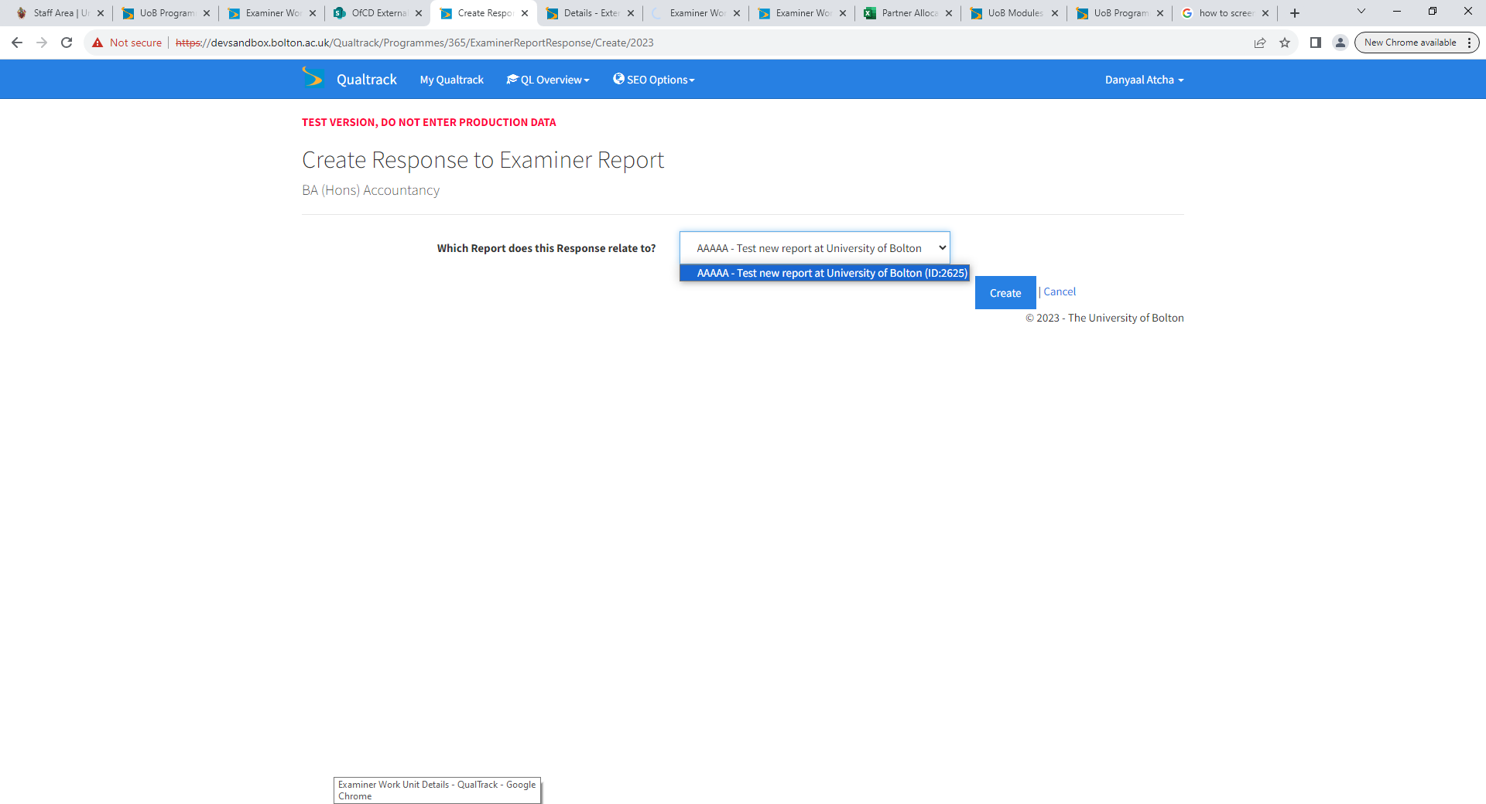

- Please enter your responses to any negative comments received to aspects 1-5 of the report and then press save.
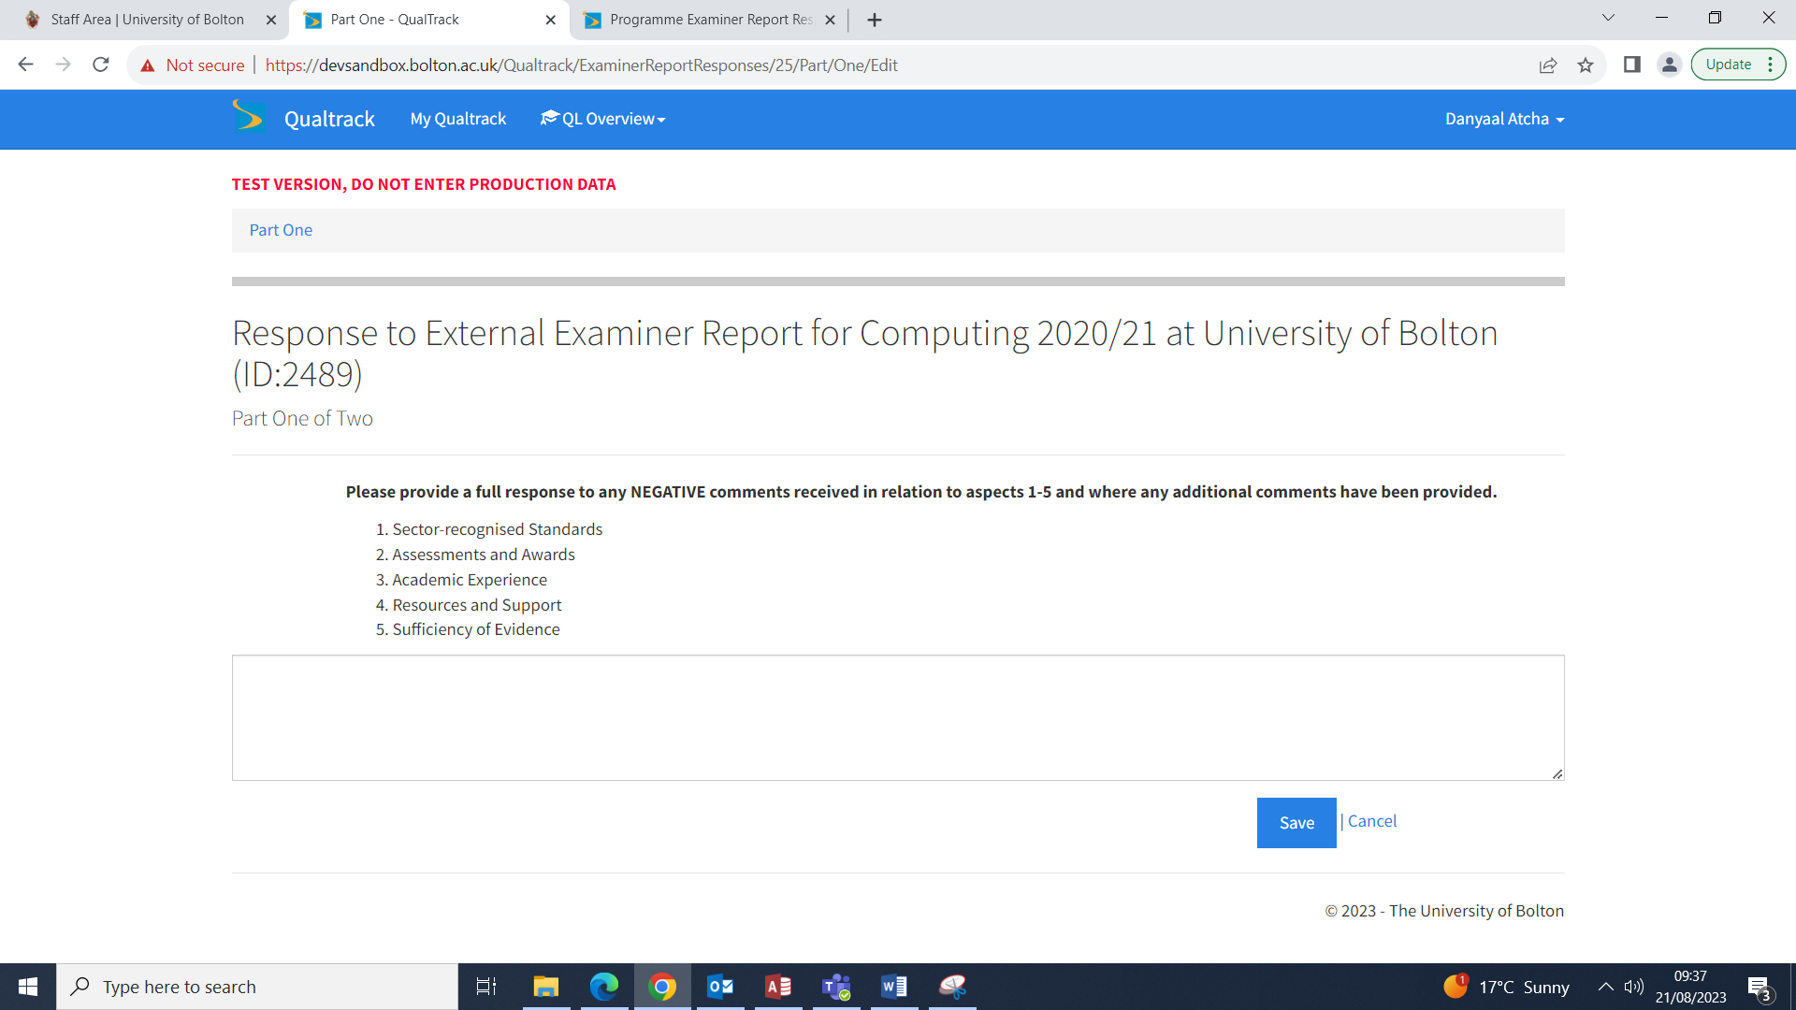

- Continue where applicable to provide comments for aspects 6-9 of the report. Once complete press save.
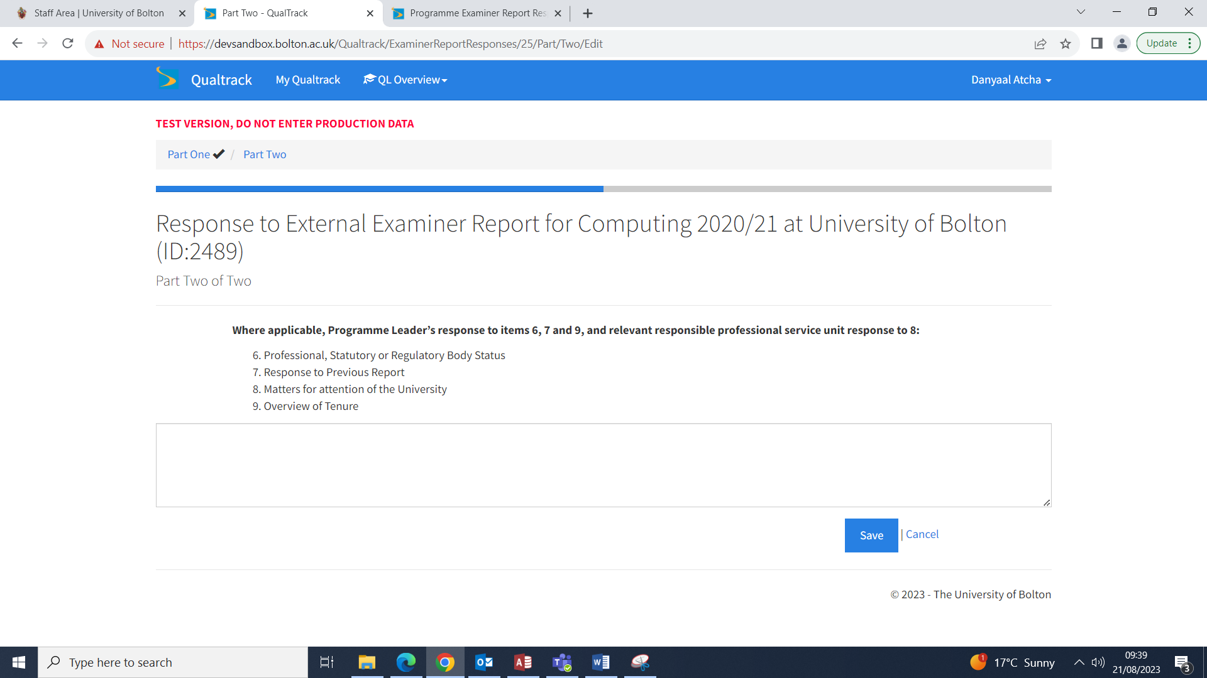

- Once the save button has been pressed an orange progress button will appear. If you are happy with the comments you have provided please press progress.
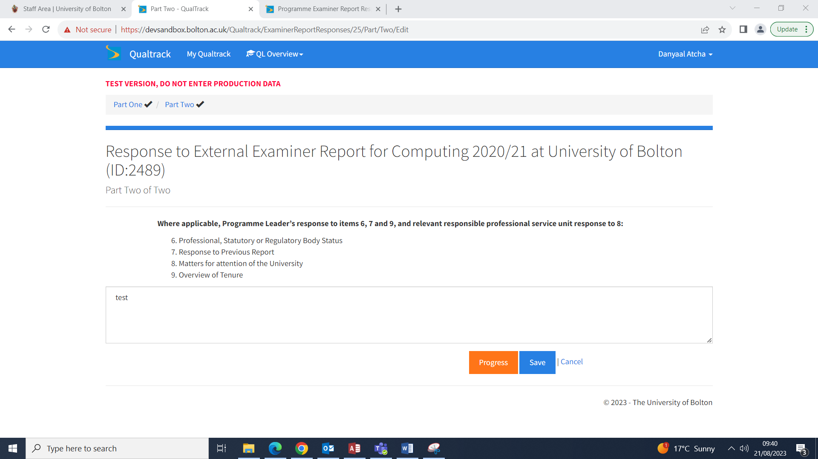
- The following message will appear prompting you to confirm you are happy with the comments provided and making you aware once the report is submitted no changes can be made. Once you are satisfied please press ok
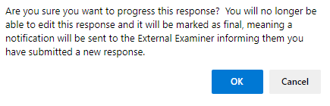
- Once a response to the EE has been submitted by the programme leader the EE will receive the following email
Dear External Examiner,
Thank you for your annual report and we are pleased to confirm that the Programme Leader has now provided a response in Qualtrack which you should be able to see when you login. Should you have any queries in relation to the response received, please do contact the Programme Leader in the first instance.
Thank you for your valuable contributions to our quality assurance and enhancement processes.
With kind regards,
Standards and Enhancement Office
University of Bolton

